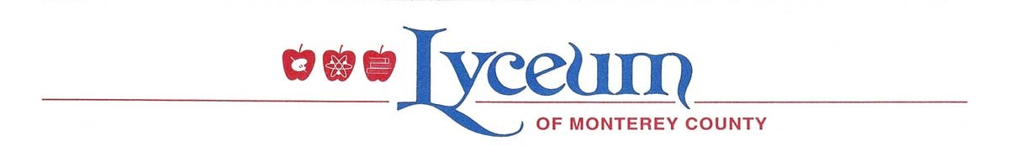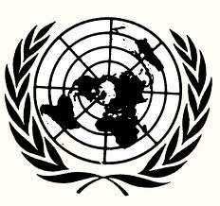

Model United Nations
Country and Committee Wish List

NAME: ____________________________

SCHOOL: ___________________________________

Have you participated in Model UN before? Circle all that apply. Leave blank if this is your first time participating in Model United Nations.

Middle School High School 1 year 2 years 3 or more years

Please list below your top 4 country choices, and top 3 committee choices. You should put your first choice in the number 1 slot, your second choice in the number 2 slot, etc.

***Please note: Only certain countries are on the Security Council and FOA Committees. If you wish to be on these committees, please double-check that your country choices are on these committees. You can find this information on page 2.

Top 4 Country Choices:  - _____________________________  - _____________________________  - _____________________________ | Top 3 Committee Choices:  - _____________________________  - _____________________________  - _____________________________

4. ______________________________

Two delegates may be assigned to each country. If you wish to work with a friend, be sure to make the same country and committee choices above, and also list that person’s name here:

I would like to work with: ____________________________

We will do our best to accommodate your choices! However, remember that you might not receive your number 1 choice, and you might not be on a delegation with your best friend. Be sure that you will be happy if you receive any of the choices on this sheet! Thank you!

Only certain countries are on the Security Council and FOA Committees.
Please double-check below that your country choices are on these committees.
(DO NOT CIRCLE COUNTRIES LISTED BELOW. WRITE CHOICES ON PAGE 1)

Countries in the Security Council:
Angola | China | Egypt | France | Japan
Malaysia | New Zealand | Russian | Senegal | Spain
Ukraine | United Kingdom | United States | Uruguay | Venezuela

Members of the General Council of the FAO:
Afghanistan | Congo | Iceland | Montenegro | Sudan
Algeria | Cote D’Ivoire | India | Nicaragua | Thailand
Argentina | Cyprus | Indonesia | Pakistan | Trinidad & Tobago
Australia | Czech Republic | Japan | Qatar | United Kingdom
Benin | Ecuador | Kenya | Republic of Korea | United States of America
Brazil | Egypt | Kuwait | Romania | Uruguay
Cameroon | Equatorial Guinea | Lesotho | Russian Federation | Venezuela
Canada | Ethiopia | Malaysia | San Marino | Zambia
Chile | France | Mali | Saudi Arabia | Zimbabwe
China | Germany | Mexico | Sri Lanka

